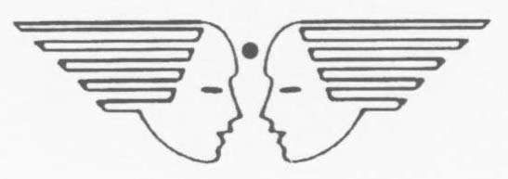

BLOOMING BUDS PLAY SCHOOL, HQ TC (U), HEBBAL
APPLICATION FOR SELECTION FOR THE POST OF ________________
______________________________________________________
(Please fill in CAPITAL LETTERS in blue/black ball pen only)

Photograph
1. Name:…………………………………………………………………
2. Address:……………………………………………………………….

………………………………………………………………………….

3. Spouse Name:………………………………………………………..

4. Profession of Spouse:……………………………………………….

5. Date of Birth:………………………………………………………….

6. Educational/Professional Qualification

COURSE | SUBJECTS | NAME OF THE UNIVERSITY | MARKS SCORED | % SCORED | DIVISION
10/+2/PUC

BA/B.Sc/B.Com

M.A/M.Sc/M.Com

NTT
B.Ed

Other qualification, If any

7. Experience:

DESIGNATION | YEAR | MONTHS | NAME OF THE SCHOOL

8. Details of Children: Age……………………… Class Studying……………………..

Age……………………….Class Studying………………………

9. Mobile Number:………………………………………………..

10. E-Mail ID:…..……………………………………………………….

11. Landline Number (if any):…………………………………..

Date: 2024 Signature of the Candidate

(Please attach self-attested photo copies of your certificates (qualification & experience) along with this proforma)

** All the posts are purely contractual and valid for the current Academic session only. The contract period will be effective from 01 Apr 2024 and will expire on 29 March of the following year (i.e. 29 Mar 2025). No payment (R) No payment for the summer vacation will be remitted to any of the staff of the Blooming Buds Play School).

For other relevant details please log on to www.bloomingbudshebbal.com and hit news flash under “Announcement heading”.

