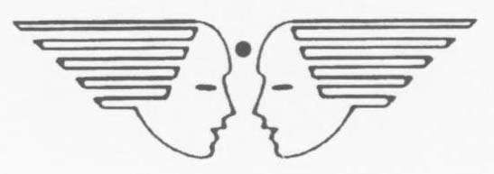

VACANCY FOR TEACHING AND NON-TEACHING STAFF:
UMEED ASHA KIRAN SCHOOL, HQ TC (U), HEBBAL

1. Applications are invited from eligible candidates for the following Teaching and Non-Teaching posts in Umeed Asha Kiran School for academic session 2024-25 on Contractual Basis**
(a) School In-charge Cum Special Educator (Fixed Rs. 16,000/- per month)

Eligibility criteria

- Graduation Degree (BA in Psychology/Others).

- Degree/ Diploma in Special Education/ Mental Retardation/ Any Certified course in Special Education.

- Experience in working with Special Children.

- Age below 50 Years.

(b) Special Educator (Autism) (Fixed Rs. 15,000/- per month)

Eligibility Criteria

- Degree/ Diploma in Autism/ Special Education/ Down Syndrom/ ADHD/ LD/ Mental Retardation/ Any certificate course in Autism/ Special education.

- Experience in working with Special Children.

- Age below 50 Years.

(c) Dance Teacher (Part Time) (Fixed Rs. 4,000/- per month)

- Degree/ Diploma/ Certified in Dance/Music.

- Age below 50 years.

(d) Ayah (Helper) (Fixed Rs. 7500/- per month)

(i) Women Candidates only

- Experience in working with Special Children.

- Age below 50 Years

NOTE for all Categories- Candidates with higher qualification and experience will be given preference.

2. All Applications are to be submitted along with photo copies of supportive documents for Educational Qualification/Experience Certificates with valid/latest contact number. The schedule for various activities are as follows: -

- Last date for submission of application is 29 Feb 2024 up to 1200hrs at Umeed Asha Kiran School, HQ TC (U), Hebbal (Except Sat, Sun Days)

- The date and time for Written Test (for School In-charge and Special educator(Autism) posts only) and Interview for all posts will be decided and disseminated in due course after receipt and scrutinization of applications.

- Interview for all posts will be held at AFFWA (L) office.

** All the posts are purely contractual and valid for the current Academic session only. The contract period will be effective from 01 Apr 2024 and will expire on 29 March of the following year (i.e. 29 Mar 2025). No payment (R) No payment for the summer vacation will be remitted to any of the staff of the Umeed Asha Kiran school).

** To download the Application form for Teaching & Non-Teaching Staff please visit the “Download” section of www.bloomingbudshebbal.com

