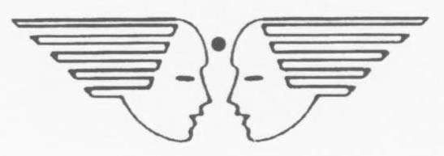

BLOOMING BUDS PLAY SCHOOL HQ TC (U), AF
CRITERIA FOR ADMISSION

Priorities for admission in Blooming Buds Play School are as under: -

Priority (a) : Wards of Serving and deceased (died while in active service) AF personnel.

Priority (b) : Wards of Ex-Air Force personnel, Children of staff working in BBPS, Ward of serving and deceased (dead while in active service) Army and Navy Personnel.

Priority (c) : Wards of serving and retired DSC personnel and children of EX-Army/ Navy personnel.

Priority (d) : Wards of Civilians paid out of Defence Estimates, Para military Force, Civilian MES Personnel, GREF, TA (When not embodied).

Priority (e): Wards of Non-Air Force personnel. Priorities for Wards of Non-Air Force personnel: -

SL No | List of priorities | Points
(i) | Parent Staying within 01 KM of radius. | 10
(ii) | Parents Staying within 02 KM of radius. | 09
(iii) | Parent/s who is/are Central Govt. Employees. | 08
(iv) | Parent/s who is/are State Govt. Employees. | 07
(v) | Parent/s who is/are serving NPF employees in the station/ unit. | 06
(vi) | Recommendation case for direct relation to Air Force Officer. | 05
(vii) | Recommendation case for direct relation to Army and Navy Officer. | 04
(viii) | Recommendation case for indirect relation to Air Force Officer. | 03
(ix) | Recommendation case for indirect relation to Army and Navy Officer. | 02
(x) | Recommendation case from Commandant of CRPF, BSF, State Govt. Officer, MP/MLA. | 01

