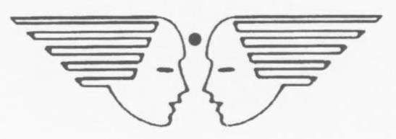

UMEED ASHA KIRAN SCHOOL, HEBBAL
HQTC (U), JC NAGAR, BANGALORE-560006

REGISTRATION FOR ADMISSION: 2024-25

Last date of submission of Registration from: 20 Feb 2024

Reg No: _________/2024-25 Date of Registration: ______Feb 2024

1. Name of the Student :- _____________________________________________________________

2. Rank/ Name of the Father :- _________________________________________________________

3. Service No :- _________________ ( ) 4. Mobile No: __________________________________

5. Mother’s Name :- _________________________________________________________________

6. Rank /Name of Ex- Air warrior (In case of biological Grandchildren) __________________________

7. Date of Birth:-____________________Age as on 01 April 2024:- ____________________________
(Please attach photo copy of Birth Certificate and AADHAAR copy of the child.)
(Age should not be less than 03 years as on 01 Apr 2024)

8. Residential Address: ______________________________________________________________

______________________________________________________________

9. Office Address: - ______________________________________________________________

______________________________________________________________

10. Landline No :- ___________________________________________________________

11. Date of Posting : ___________________________ 12. Unit:______________________________

13. Date of Living out : ________________________________________________________________

14. Distance from Residence: __________________kms

15. Priority /Category:
Priority  No | Category | Tick the applicable  category
a | Wards of Serving and deceased (died while in active service) Air Force personnel and wards of serving NCs (E).
b | Wards of Ex-Air Force personnel, Children of staff working in Blooming Buds Play School, Ward of serving and deceased (dead while in active service) Army and Navy Personnel.
c | Wards of serving and retired DSC personnel and children of EX-Army/ Navy personnel
d | Wards of Civilians paid out of Defence Services estimates, Para military Force, Civilian MES Personnel, GREF, TA (When not embodied).
e | Wards of Non-Air Force Personnel. (Pure civilian)

Note:

1. For admission under Biological Grand-children of Air Warriors, photo copy of the relevant page of Discharge Book/ Order is to be mandatorily attached.

2. The Registration for admission does not automatically guarantee admission in to the Umeed Asha Kiran School, HQ TC (U), Hebbal. Admission is subject to availability of vacancy after completion of admission process for the “Wards of Air Force Personnel” and in the order of Priority Categories. The “Priority Category” of candidates is mentioned in Para 12 of the “Registration Form”

UNDERTAKING BY PARENT

I, Rank /Name ____________________________________________________ am aware that the above registration for admission of my ward (Name) ____________________________________________ does not automatically guarantee admission in to “Umeed Asha Kiran School” and the admission is subject to availability of vacancy. I will not make any claim, if admission is not granted to my ward due to shortage of vacancies or not meeting there required QRs for admission.

Date: Feb 2024 Signature of Parent

* Other relevant details can be obtained from the School’s Web Page http://www.bloomingbudshebbal.com

