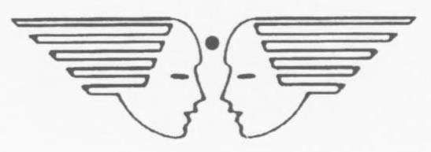

VACANCY FOR TEACHING AND NON-TEACHING STAFF
BLOOMING BUDS PLAY SCHOOL, HQ TC (U), HEBBAL

1. Applications are invited from eligible candidates for the following Teaching and Non-Teaching posts in Blooming Buds Play School for academic session 2024-25 on Contractual Basis**.

(a) School In-Charge cum Teacher (1 post) (Fixed Rs. 14,000/- per month)

Essential Qualification

- Graduation alongwith NTT.

- Age below 45 years at the time of appointment (relaxable for better qualified and experienced candidates)

Preference will be given to candidates with following additional qualification

- Degree or Diploma in Education.

- Diploma or certificate in early Childhood care and Education, Child Psychology, First Aid or Elementary Life Skill.

- At least 02 years teaching experience.

(b) Teacher (02 Posts) (Fixed Rs. 12,000/- per month)

Essential Qualification

- Graduation alongwith NTT.

- Age below 45 years at the time of appointment (relaxable for better qualified and experienced candidates)

Preference will be given to candidates with following additional qualification

- Degree or Diploma in Education.

- Diploma or certificate in early Childhood care and Education, Child Psychology, First Aid or Elementary Life Skill.

- At least 02 years teaching experience.

(c) Clerk cum Accountant (One Post) – To look after accounts of both : Blooming Buds Play School and Umeed Asha Kiran School) (Fixed Rs. 8,000/-)

Essential Qualification

- Graduation (B. Com/ BBM) from Govt recognized University with Knowledge of accounts and book-keeping.

- Basic Knowledge of Computer Applications, especially MS Excel and MS Office.

- Age below 50 years.

(d) Ayah (Helper) (Three posts) (Fixed Rs. 6,500/- per month)

(i) Women Candidates only

(ii) Age below 50 Years

NOTE (for all Categories) - Candidates with higher qualification and experience will be given preference.

2. All Applications are to be submitted alongwith photo copies of supportive documents for Educational Qualification/Experience Certificates with valid/latest contact number. The schedule for various activities is as follows: -

- Last date for submission of application is 29 Feb 2024 upto 1200hrs at Blooming Buds Play School, HQ TC (U), Hebbal (except Sat, Sun Days)

- The date and time for Written Test (for School In-charge and Teacher posts only) and Interview for all posts will be decided and disseminated in due course after receipt and scrutinization of applications.

- Interview for all posts will be held at AFFWA (L) Office.

** All the posts are purely contractual and valid for the current Academic session only. The contract period will be effective from 01 Apr 24 and will expire on 29 March of the following year (i.e. 29 Mar 2025). No payment (R) No payment for the summer vacation will be remitted to any of the staff of Blooming Buds Play School.

** To down load the Application form for Teaching & Non-Teaching Staff please visit the “Download” section of www.bloomingbudshebbal.com

